Custom Build Image containerize on ECS Cluster using Separate VPC Cluster

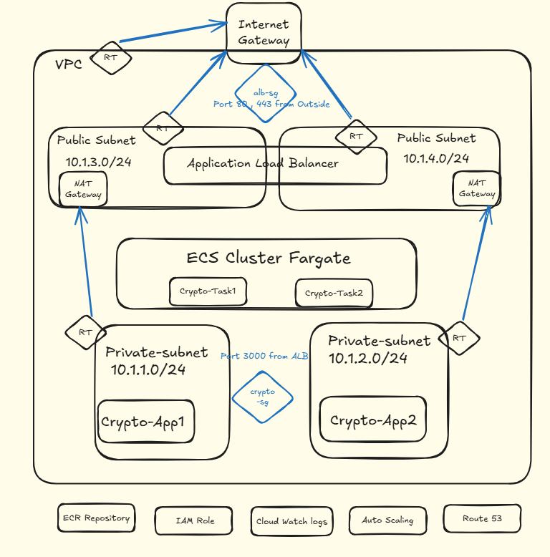

## Basic Network setup

step1: Create a vpc with cidr block 10.1.0.0/16

step2: create 2 private subnet (10.1.1.0/24, 10.1.2.0/24) and 2 public subnet (10.1.3.0/24, 10.1.4.0/24)

step3: Create private and public route tables and associate subnet to respective route tables

step4: Create 1 internet gateway and attach it to vpc

step5: create public route -> from anywhere to internet gateway

step5: Create 2 nat gateway, 1 for each public subnet

step6: Create private route from everywhere to nat gateway for outbound

## Security group setup

step1: 1 security group for alb -> inbound on port 80 and 443 (http and https) from everywhere

step2: 1 security group for crypto app (inbound on port 3000 as we run the app in this port) from alb securty group

# Create a ecr repo

step1: create the ecr repo

step2: note down the detailss

step3: build the ecr login command

## containerise the app

step1: setup the crypto app, dockerfile, etc

step2: write a github action to build and push the image to ecr

step3: configure the secrets and build the image, ecr login and push to repo

## ECS deployment

step1: create a ecs cluster

step2: create a task definition with the flask image, a cloud watch log group, ecs execution role(that has access to ecr)

step3: create an ecs service using private subnet pubic ip disabled, ecs security group

step4: associate an alb while creating the ecs service that has a http listener on port 8000(as per the app) and target group

step5: access the app using load baancer dns

## DNS

step1: register a domain

step2: create public dns zone

step3: create a route from the domain(or subdomain) to load balancer using alias config

step4: test accessing the app with domain

### ssl config

step6: create a certificate with aws acm

step7: Do the certificate validation with the domain

step8: create a https listener

step9: access the app on domain name on https

Custom Application = Crypto App

Structure file

Dockerfile

Docker image

Crypto-app and Tagged image

ECR Repository

Pushed the image to AWS ecr repository

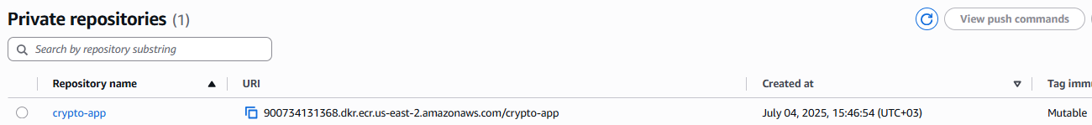

Security Group

ECS Cluster

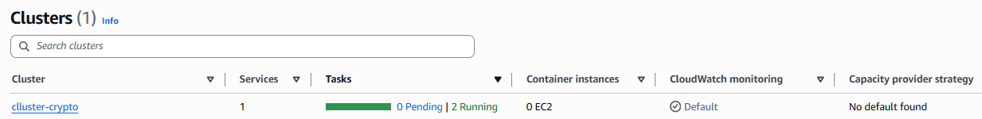

Service

Task

Task definition

Loadbalancer

VPC

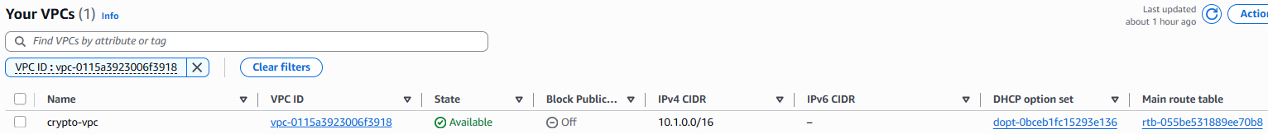

Subnets

Route Tables

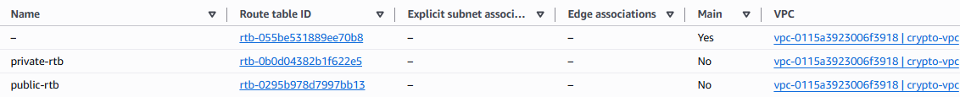

VPC Route table

Private Route Table

Public Route Table

Internet GW



Nat-Gateway



Route 53

A Record Details

Accessing Application from public domain

<http://zeroshellsecops.cloud>

